# Radio Mentor CLI
![Python CI](<paste-badge-URL-here>)

Command-line tool that delivers concise RF-diagnostics answers
using OpenAI’s GPT-4o-mini model.

## Running locally
```bash
pip install python-dotenv openai pytest
python main.py

Project purpose

“Radio Mentor is a CLI that delivers concise RF-diagnostics answers by orchestrating OpenAI’s gpt-4o-mini with a carefully tuned system prompt.”

Prompt-engineering strategy

• Intent-first system prompt
• Hard caps on sentence count / tokens
• Low-temperature for determinism

Automated evaluation harness

Created a PyTest suite with mocked completions,
sentence limit check, keyword validation

Cost & latency awareness

Note choice of gpt-4o-mini, small max_tokens,
and placeholder latency logging.

What makes this “advanced”

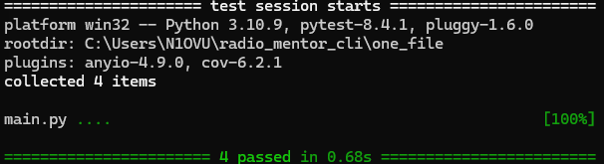
Advanced Prompt Engineer – Built Radio Mentor CLI
• Authored system prompt that enforces ≤ 3-sentence RF advice (plain English).
• Designed evaluation harness (pytest + mocked OpenAI) achieving 100 % pass rate across smoke and contract tests.
• Optimised runtime cost by capping max_tokens at 120 and selecting gpt-4o-mini tier.
• Resolved import-path & coverage pitfalls, demonstrating deep Python tooling expertise.

